1. **Dependency:**
   1. 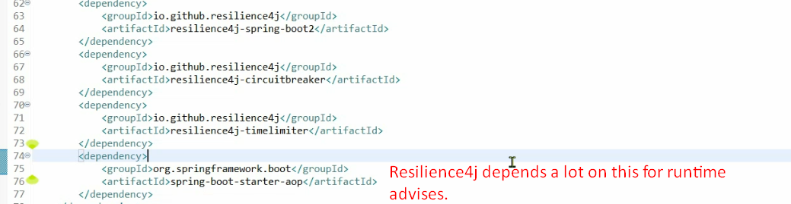
2. @CircuitBreaker:  
   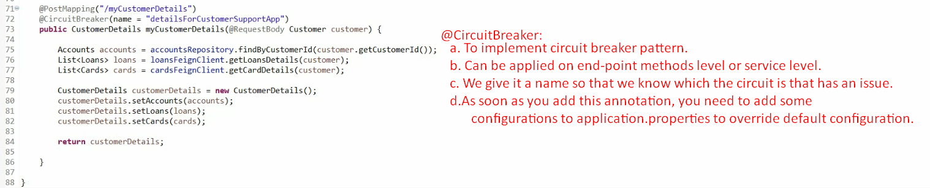
3. **application.properties**:
   1. 
      1. The purpose of this property is to inform Resiliency4j to register all circuit related health information to actuator so that I can see inside my actuator what kinds of circuit breakers that I have, what are their health, their state etc.
      2. By default, this is disable.
   2. 
      1. Circuit Breaker Pattern would monitor 5 calls to take decision whether it should go into OPEN state or not.
   3. 
      1. If 50% of calls which are being monitored (in our case, it is 5) are failed, the circuit would go into OPEN state.  
         So, 50% of 5 calls = 3 calls.  
         Means, it will fail fast when will give default configured response back.
      2. Default value is 90%.
   4. 
      1. After 30 seconds (30000miliseconds), it will come out of OPEN state into HALF_OPEN state.
      2. Default is 90seconds.
   5. 
      1. When the circuit is in HALF_OPEN state, only 2 calls are allowed.
      2. If 50% of them gets failed, the circuit will go into OPEN state.